Amber Dolezal

**Plan to Complete the Design:**

The Conceptual Design Report must include a plan to complete the design. This does not need to include every detail but should have most of the scheduling mapped out to the end of the project. Time should be allotted for finalizing the design, ordering parts, prototyping, construction, testing, and making final adjustments to the design. Project milestones should be highlighted. The Gantt Chart and Project Plan should be updated until the end of the project at this point. It may be helpful to include these charts in the

conceptual design document in a summarized form.

--------------------------------------------------------------------------------------------------

**Phase 1 (Mar 4, 2022 – Apr 15, 2022):** Research was conducted on AR devices and remote rendering applications by the entire team. The entire team consulted with Dr. Omid Semiari to get the specifics of the project. William B. Micheal was contacted in order to collect the equipment that will be utilized for the duration of this project: a HoloLens One and a WiFi AX1800 Dual Band Wireless Access Point Router. The Requirements and Specification Document was written including defining team and project sponsors, the project specification intent, project requirements, parameters and target values, and the agreement to the project specification.

**Phase 2 (Apr 15, 2022 – May 6, 2022):** During Phase 2 the team worked on the Requirements and Specifications Presentation. This presentation went over the project’s problem, current standards, constraints, the requirements and specifications, the system design expectations, issues, timeline, budget, and societal concerns.

**Phase 3 (Aug 26, 2022 – Sept 12, 2022):** Phase 3 was focused on writing the Conceptual Design Report excluding the Testing Report. In this report the team has put together a decision matrix, concept recommendation, a plan to complete the design, and the testing plan.

**Phase 4 (Sep 9, 2022 – Sep 16, 2022):** The Conceptual Design Presentation will be created and given in Phase 4. This presentation will present a summary for each section of the report that was put together in the previous phase.

**Phase 5 (Sep 16, 2022 – Oct 7, 2022):** In this stage each member of the team will contribute to the Critical Design Documents including Detailed Description of Design, User Manuals, and Instructions, Detailed Drawings of parts, Schematics, Software Descriptions, Bill of Materials.

**Phase 6 (Oct 8, 2022 – Nov 20, 2022):** Although the team has been working on the actual design of the project since May, this phase the team will be solely focused on completing the AR Blackjack Assistant Remote Rendering Application which will also incorporate the application’s testing.

**Phase 7 (Nov 6, 2022 – Dec 7, 2022):** In this part of the project the team will finish the Conceptual Design Documents by writing the Testing Report. This will summarize the testing that was completed at the end of Phase 6.

**Phase 8 (Nov 24, 2022 – Dec 9, 2022):** A final presentation will be developed and given discussing the project, problem, conceptual design, finalized design, and the testing and analysis.

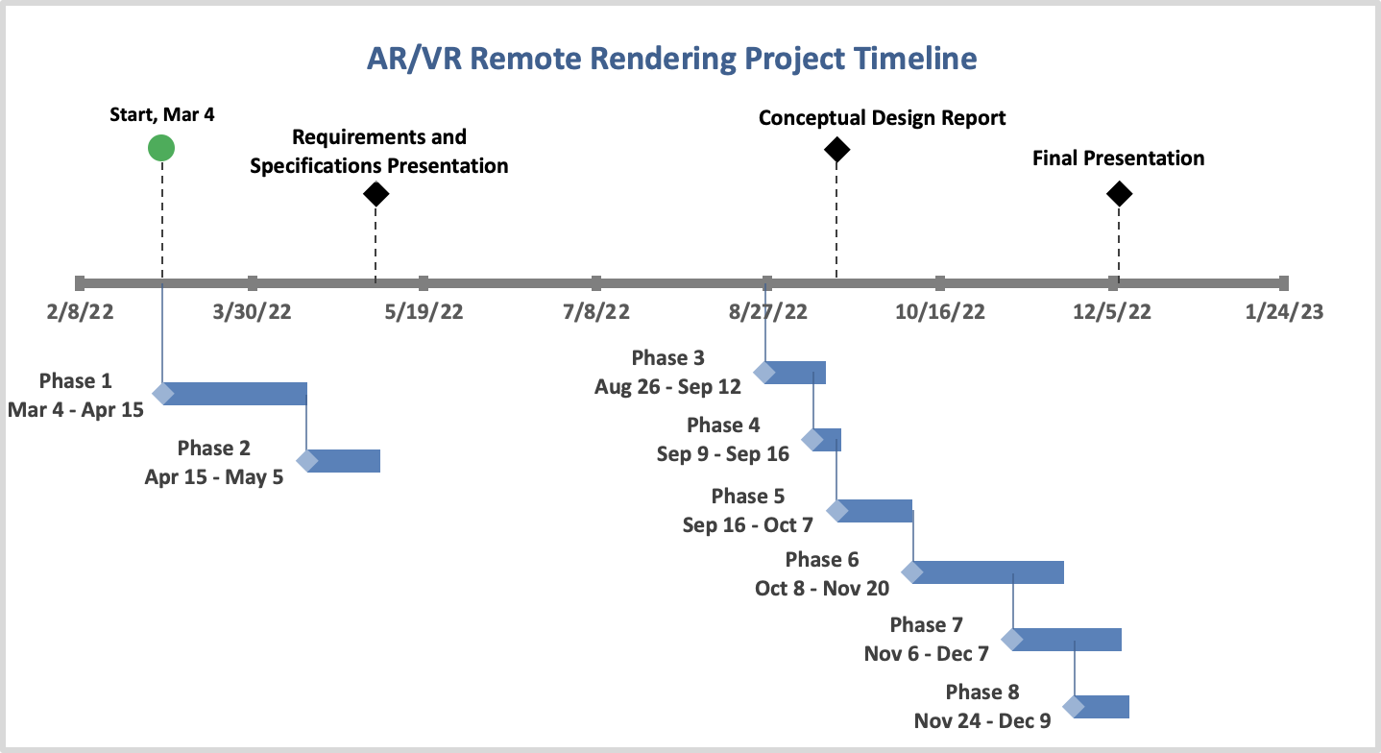

Gantt Chart will be added at the end of the project.